Time to explore get thumbnail API now. You must have been familiar with using Microsoft Computer Vision API quite a lot now.

The official document about this API can be found here.

<https://westus.dev.cognitive.microsoft.com/docs/services/56f91f2d778daf23d8ec6739/operations/56f91f2e778daf14a499e1fb>

According to the official document, this API makes an thumbnail in a size the user wants. When user input width, and height the user desire the picture to be then this API makes that specific-sized thumbnail as a result. The point of Microsoft Computer Vision get thumbnail API is it crops the picture based on ROI(Region Of Interest). So it crops the important part of the picture with intelligence in any size.

There is a console also you can test Microsoft Computer Vision API which is called OPEN API testing console.

Link is here

<https://southeastasia.dev.cognitive.microsoft.com/docs/services/56f91f2d778daf23d8ec6739/operations/56f91f2e778daf14a499e1fb/console>

You can input some values including your API key, width, height, and the picture URL. And the request URL and HTTP request will be like below. And it seems it worked well.

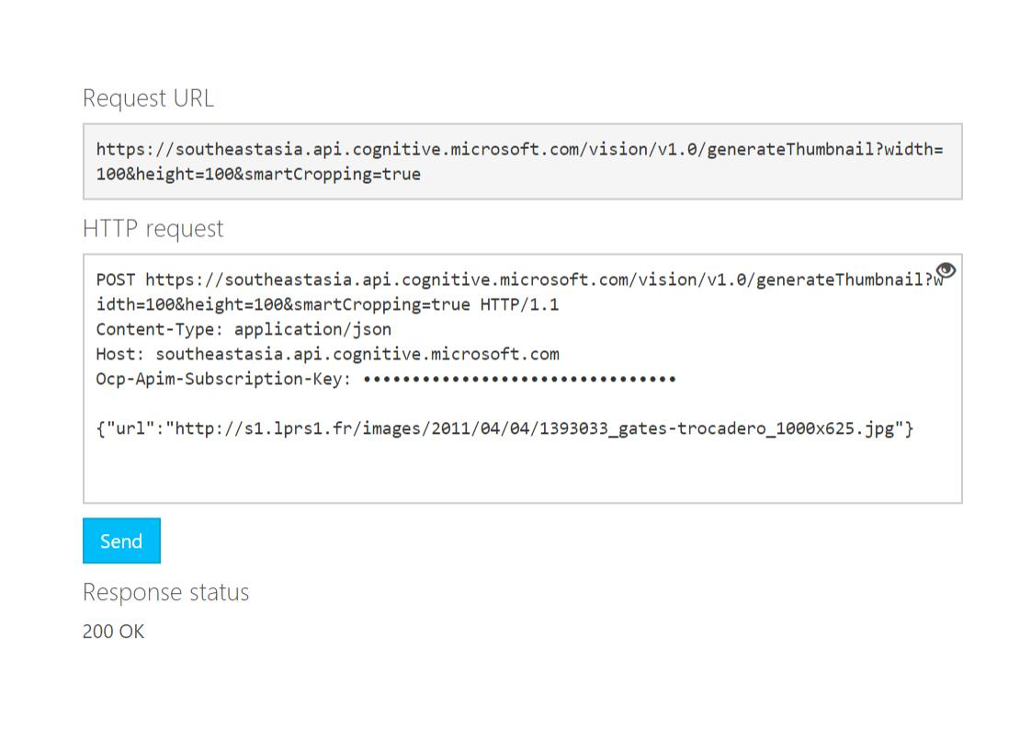

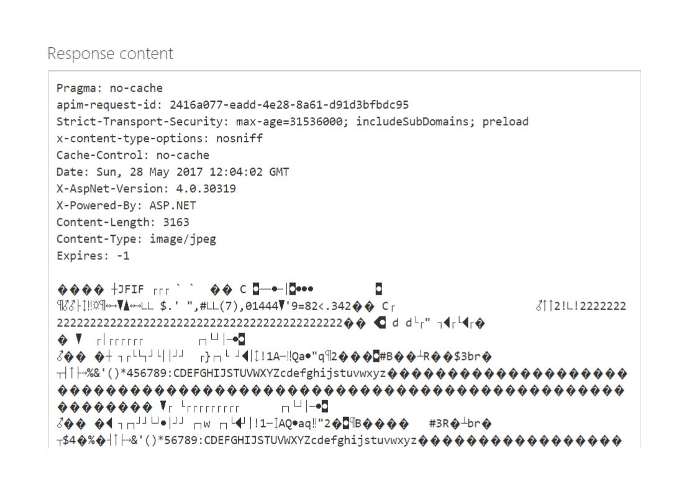

You must have this result. It did work well. Good request and Good respond, but why can not see a thumbnail we want? That’s why I said dealing with this API is quite trickier. The official document says it returns [Binary image data].

Dealing with Binary image data to display on the web browser needs extra work. Binary image data should be encoded to base64 style, which means we have to encode the file but this is a subject beyond what we learnt from CS290 so we can skip this and we can just check whether our request and response work well.